ELEGANCE SALON
Salon Management System
Developer Guide
Technical documentation: installation, architecture, database design with ER diagram, core algorithms, security and testing.
Project detail
Project | eProject: Salon Management (PHP + MySQL)
Supervisor | Miss Anumta Alam
Batch | 2512E1
Group | ______________________

Serial No. | Enrollment Number | Student Name
1 | 1717572 | Ayesha Farooq
2 | 1717573 | Ibra Ali
3 | 1718286 | Muhammad Qasim
4 | 1718218 | Wania Kaleem

Version 1.0 | October 2026

Contents
1 Overview and Tech Stack
2 Installation and Setup
3 Project Structure
4 Architecture
5 Database Design (ER Diagram, Data Dictionary)
6 Core Logic: Slots, Booking, Roles
7 Page and Module Reference
8 Security
9 Configuration and Scheduled Tasks
10 Testing Checklist
11 Known Limitations and Future Work

1 Overview and Tech Stack
Elegance Salon Management System is a plain PHP application with a MySQL/MariaDB database. It uses no framework and no Composer packages, so it runs on any XAMPP or WAMP installation. It meets the eProject requirements: home page, role-based access (admin, receptionist, stylist), appointment booking with free-slot lookup, client, inventory and staff management, reports, payments and invoices, notifications, contact and feedback.
Layer | Technology
Language | PHP 7.4 or newer (strict use of PDO, password_hash, random_bytes)
Database | MySQL / MariaDB, InnoDB, utf8mb4, 12 tables
Web server | Apache 2.4 with .htaccess (XAMPP / WAMP)
Front end | Server-rendered HTML, one stylesheet (assets/css/app.css), one script (assets/js/app.js), no libraries
Fonts / icons | Local font files in assets/fonts; inline SVG icons from icon() in helpers
Email | PHP mail() wrapped by notify(), every attempt logged in notifications
Scheduling | cron/send_reminders.php run daily by Task Scheduler or cron
Size: about 3,900 lines of PHP, CSS and JavaScript across 40 source files. Almost all shared logic lives in one file, includes/helpers.php (582 lines).

2 Installation and Setup

2.1 Requirements
- XAMPP or WAMP with Apache and MySQL started, PHP 7.4 or newer with the pdo_mysql extension.
- A browser. No Node, Composer or build step.

2.2 Steps
- Copy the elegance-salon folder into htdocs (XAMPP) or www (WAMP).
- Start Apache and MySQL.
- In phpMyAdmin choose Import and import database/elegance_salon.sql. It creates the elegance_salon database, all tables and starter data (10 services, 4 stylists, working hours Monday to Saturday 09:00 to 18:00, 8 stock items, default settings). Alternatively open check.php, which tests PHP, the PDO driver and the database and can install the database for you.
- If MySQL is not root with an empty password, or runs on another port, edit config.php (DB_HOST, DB_PORT, DB_NAME, DB_USER, DB_PASS) and set APP_TIMEZONE (default Asia/Karachi).
- Open http://localhost/elegance-salon/setup.php and create the first administrator (password of at least 10 characters). This page works only while the users table is empty.
- Sign in at /admin/login.php. In Settings replace the placeholder phone, email, address and hours; in Staff replace the four sample stylists.

2.3 Deployment notes
- Set APP_DEBUG to false on a live server (it is false by default).
- Serve over HTTPS; the session cookie becomes Secure automatically when HTTPS is detected.
- Apache must allow .htaccess (AllowOverride All) so that includes/, cron/ and database/ stay blocked.
- Make assets/img/uploads/ writable by the web server. It receives service and staff photos.

3 Project Structure
elegance-salon/
|-- index.php services.php contact.php feedback.php public pages
|-- book.php booked.php manage.php booking flow
|-- slots.php JSON endpoint: free times for a service/date
|-- ics.php calendar file download (.ics)
|-- setup.php one-time first-admin creation
|-- check.php environment and database installer check
|-- config.php database and timezone constants
|-- .htaccess directory listing off, config.php denied
|-- admin/ staff area (13 modules + login/logout)
| |-- index.php appointments.php calendar.php clients.php
| |-- services.php staff.php inventory.php payments.php
| |-- reports.php feedback.php notifications.php
| |-- users.php settings.php login.php logout.php
|-- includes/ bootstrap.php helpers.php
| public_header/footer.php admin_header/footer.php
|-- cron/send_reminders.php CLI only
|-- database/elegance_salon.sql schema + starter data
|-- assets/ css/app.css js/app.js fonts/ img/ img/uploads/

Every page starts with require includes/bootstrap.php. Bootstrap loads config.php, sets the timezone and error handling, defines BASE_URL, loads helpers.php, sends security headers and starts the session ELEGANCESESS. Pages in /admin call require_module() first; it redirects guests to the login page and shows a 403 page to users without access.

4 Architecture
The application is a classic server-rendered, page-per-file PHP site. There is no router or MVC layer: each page contains its request handling (top of file) and its HTML (bottom of file), and shares helpers through includes/. The one AJAX call is slots.php, which returns JSON for the booking form.
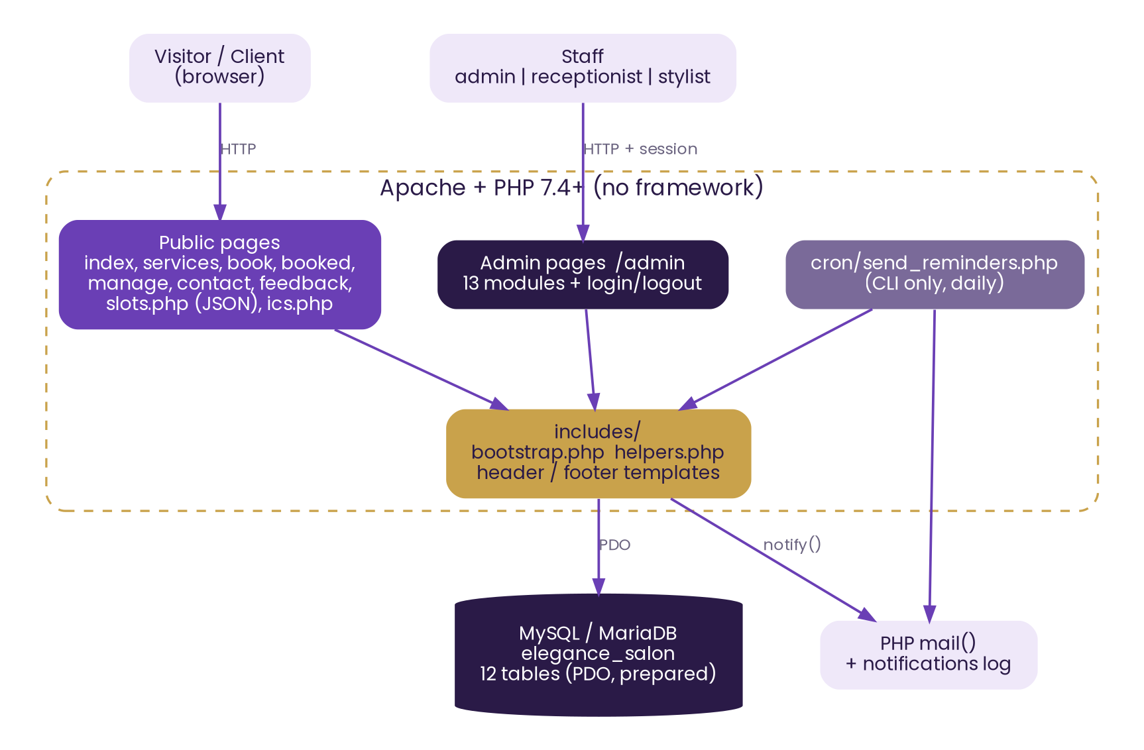
Figure 1: System architecture

Request lifecycle of a form page
- bootstrap.php loads config, helpers and the session.
- On POST: csrf_verify() checks the token; input is read with post_str() (trimmed, length-limited).
- Validation errors are collected into an array and shown above the form; no data is written.
- Valid data is saved with prepared statements through q().
- The page calls flash() and redirect() (Post/Redirect/Get), so a refresh does not resubmit.

5 Database Design
The database elegance_salon has 12 InnoDB tables. Eight tables form the connected core (clients, staff, services, appointments, payments, staff_services, staff_shifts, users); four are standalone (settings, inventory_items, feedback, notifications). Foreign keys use ON DELETE CASCADE for link tables, SET NULL for optional links, and no action (restrict) for the three keys on appointments, so history cannot be orphaned.

5.1 Relationships
Relationship | Cardinality | Notes
clients → appointments | 1 : many | appointments.client_id, restricted delete
staff → appointments | 1 : many | appointments.staff_id, restricted delete
services → appointments | 1 : many | appointments.service_id; price is copied at booking time
clients → payments | 1 : many | payments.client_id
appointments → payments | 1 : 0..many | payments.appointment_id nullable (walk-in sales); SET NULL on delete
staff ↔ services | many : many | link table staff_services, cascade delete
staff → staff_shifts | 1 : many | one row per weekday (unique on staff_id + weekday)
staff → users | 1 : 0..many | users.staff_id links a stylist login to a profile
staff → clients | 1 : 0..many | clients.preferred_staff_id, SET NULL

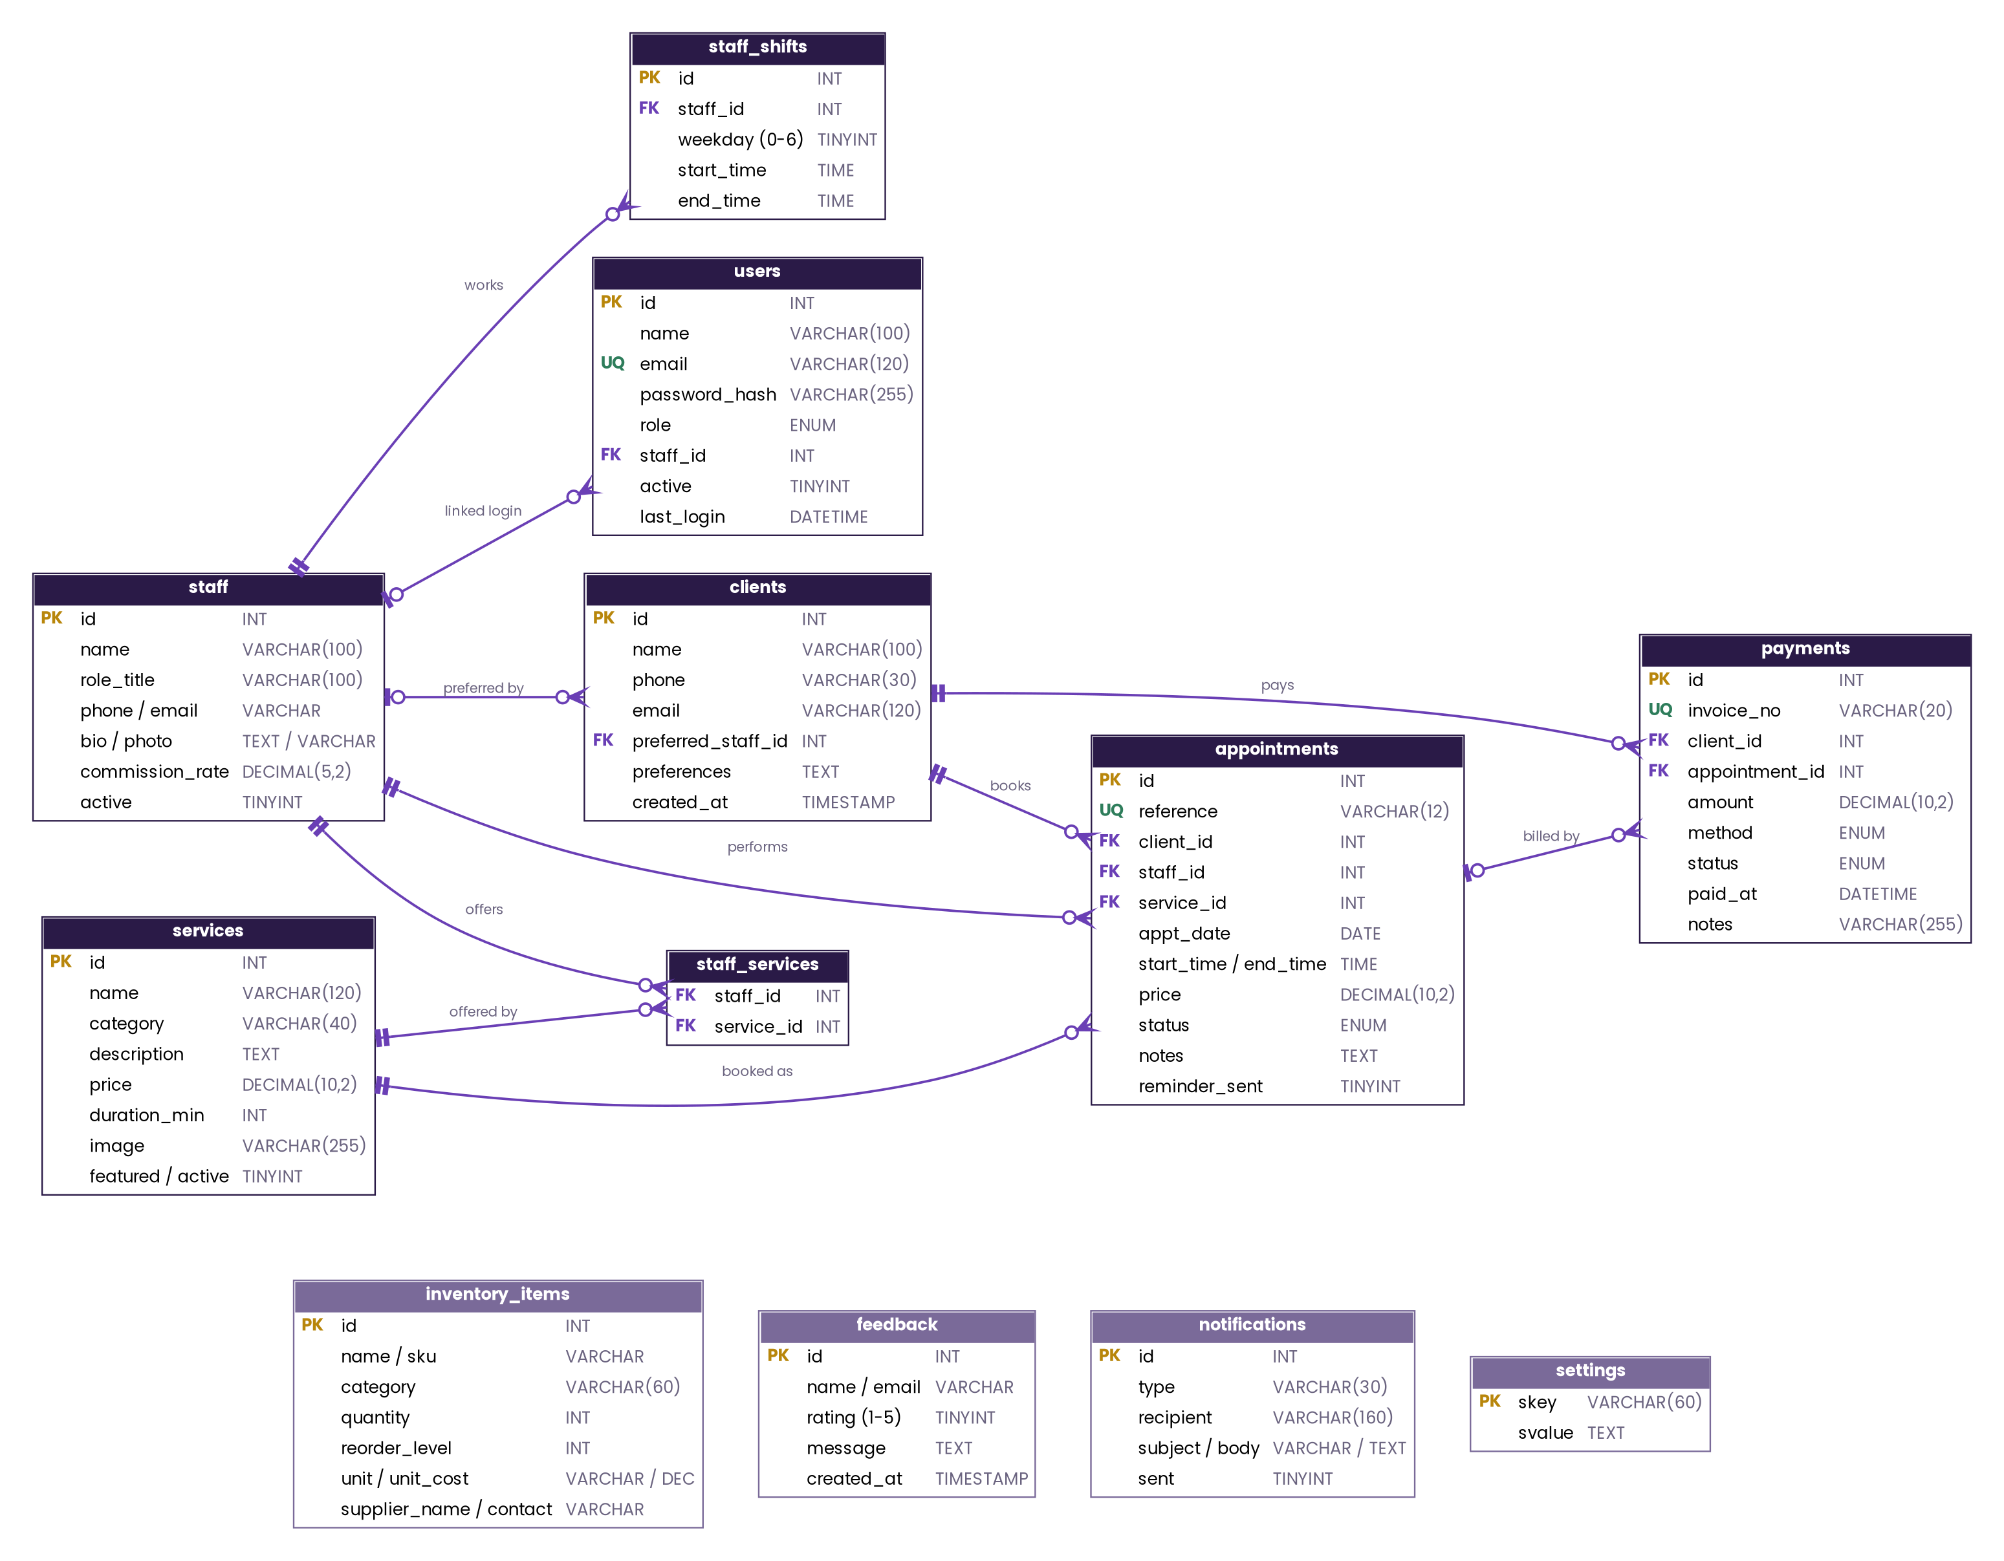
Figure 2: Entity-relationship diagram. PK primary key, FK foreign key, UQ unique. Grey tables are standalone. A full-size PNG is supplied separately.

5.2 Data dictionary

appointments
One booking. Price and end time are stored on the row so later changes to a service do not rewrite history.
Column | Type | Notes
id | INT PK | Auto increment
reference | VARCHAR(12) UQ | Public code, format ES + 6 hex characters
client_id, staff_id, service_id | INT FK | Required
appt_date | DATE | Indexed
start_time, end_time | TIME | end = start + service duration
price | DECIMAL(10,2) | Copied from services.price
status | ENUM | confirmed, completed, cancelled, no_show
notes | TEXT | Client note
reminder_sent | TINYINT | Set by the reminder job; reset on reschedule

clients
A person who has booked. Matched by phone number.
Column | Type | Notes
id | INT PK
name, phone | VARCHAR | Phone indexed; digits-only form via clean_phone()
email | VARCHAR(120) NULL | Optional
preferred_staff_id | INT FK NULL | Preferred stylist
preferences | TEXT NULL | Free text
created_at | TIMESTAMP

staff
Salon team profile (not a login).
Column | Type | Notes
id | INT PK
name, role_title | VARCHAR
phone, email, bio, photo | VARCHAR/TEXT NULL
commission_rate | DECIMAL(5,2) | Percent of paid revenue, used in Reports
active | TINYINT | Inactive staff get no new bookings

services
The bookable menu.
Column | Type | Notes
id | INT PK
name, category, description | VARCHAR/TEXT | Category: Hair, Nails, Skin, Makeup
price | DECIMAL(10,2)
duration_min | INT | Used for slot length
image | VARCHAR(255) NULL | Path under assets/img
featured, active | TINYINT | Featured shows on Home; inactive hides it

staff_shifts
Weekly working hours. weekday 0 = Sunday to 6 = Saturday.
Column | Type | Notes
id | INT PK
staff_id | INT FK | Cascade delete
weekday | TINYINT | Unique with staff_id
start_time, end_time | TIME | No row = day off

payments
A payment or invoice.
Column | Type | Notes
id | INT PK
invoice_no | VARCHAR(20) UQ NULL | Format INV-YYYY-00001, set after insert
client_id | INT FK
appointment_id | INT FK NULL | Null for walk-in sales
amount | DECIMAL(10,2)
method | ENUM | cash, card, online
status | ENUM | paid, pending, refunded
paid_at | DATETIME NULL | Null while pending

users
Staff logins.
Column | Type | Notes
id | INT PK
email | VARCHAR(120) UQ | Lower-cased
password_hash | VARCHAR(255) | password_hash() (bcrypt/default)
role | ENUM | admin, receptionist, stylist
staff_id | INT FK NULL | Required for a stylist to see appointments
active | TINYINT | 0 blocks sign in
last_login | DATETIME NULL

inventory_items
Salon supplies.
Column | Type | Notes
id | INT PK
name, sku, category | VARCHAR
quantity, reorder_level | INT | Low stock when quantity <= reorder_level
unit, unit_cost | VARCHAR/DECIMAL
supplier_name, supplier_contact | VARCHAR NULL
Other tables: staff_services (staff_id, service_id, composite primary key), feedback (name, email, rating 1 to 5, message), notifications (type, recipient, subject, body, sent) and settings (skey primary key, svalue). Settings keys: salon_name, tagline, phone, email, address, hours, currency, slot_interval, booking_min_notice_hours, booking_window_days.

6 Core Logic

6.1 Free slot calculation
available_slots($service_id, $date, $staff_id) is the heart of booking. For each eligible active stylist (eligible_staff() joins staff_services) it calls staff_slots():
- Load the stylist’s shift for that weekday. No shift means no slots.
- Step from shift start to shift end in slot_interval minutes (default 30), requiring that the service duration still fits before shift end.
- Skip start times earlier than now plus booking_min_notice_hours.
- Load that day’s appointments that are not cancelled or no-show, and drop any start time whose interval overlaps (t < busy_end AND t + duration > busy_start).
- Merge across stylists. When the client chose “Any available stylist” the first stylist free at each time is attached to the slot, so the value posted is HH:MM@staffId.
The date must be today or later and within booking_window_days. Staff creating an appointment in the admin area pass ignoreNotice so they can book at short notice.

6.2 Safe booking
book_appointment() prevents double booking with a transaction. It begins a transaction, locks the stylist row with SELECT ... FOR UPDATE, recalculates the free slots, and inserts only if the requested time is still free; otherwise it throws “Sorry, that time was just taken”. Two clients racing for one slot are therefore serialised by the lock. The reference number comes from new_reference() (ES + 6 random hex characters, retried until unique).
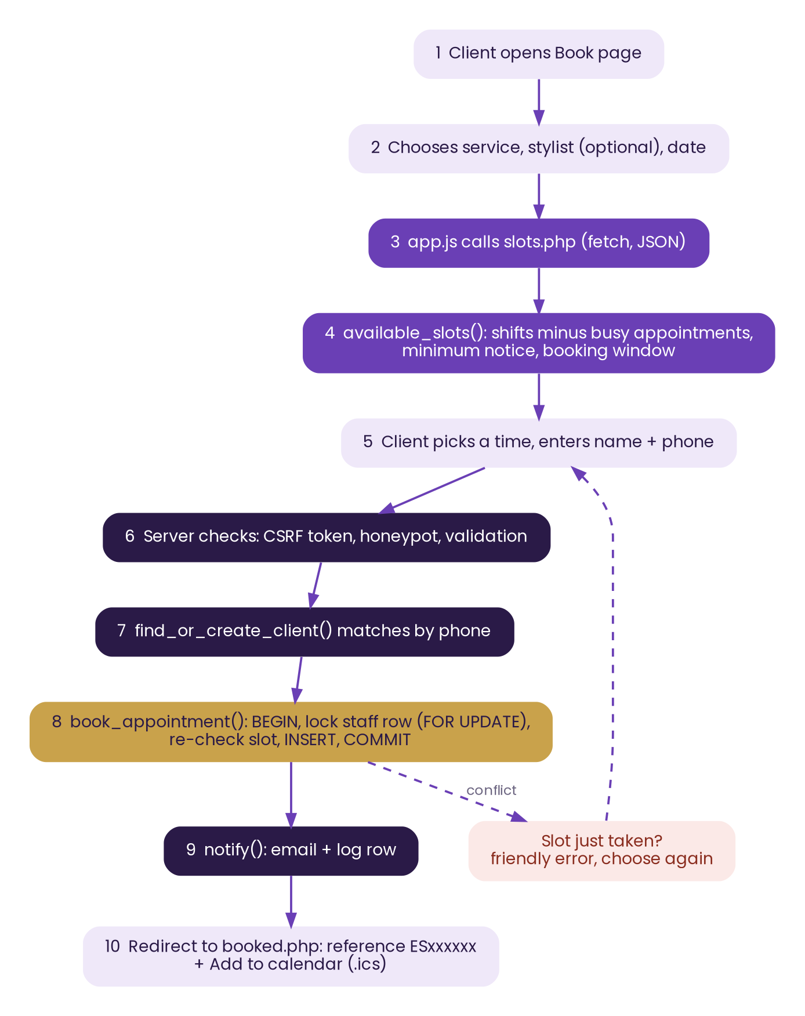
Figure 3: Online booking flow

6.3 Roles and access
role_modules() returns the module list for each role. can($module) tests the current user and require_module() enforces it on every admin page; the sidebar is built with the same can() call, so hidden menu items and blocked pages never disagree. Stylists are further restricted inside appointments, calendar and dashboard by is_stylist(), which adds staff_id = own to the queries, and own_check() rejects edits to other stylists’ rows.
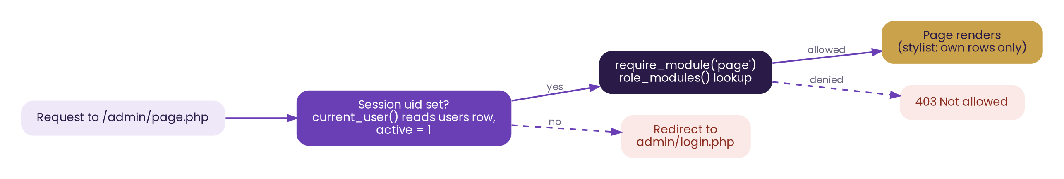
Figure 4: Admin access check

6.4 Other helper functions
Function | Purpose
q(), fetch_all(), fetch_one(), fetch_val() | Prepared-statement wrappers around PDO
e() | HTML-escape output
csrf_field(), csrf_verify() | Per-session CSRF token for every form
flash(), flash_render() | One-time success or error banners
post_str(), get_str() | Trim and length-limit input
find_or_create_client() | Match a client by phone or create one; fills a missing email
notify() | Send mail and always log a row in notifications
appointment_full() | Appointment joined with client, staff and service
handle_image_upload() | Validate and store service or staff photos
paginate(), pager() | List paging, 15 rows per page
money(), fmt_date(), fmt_time(), badge() | Display formatting

7 Page and Module Reference
File | Role | What it does
index.php | Public | Home: hero, popular (featured) services, about, team, call to action
services.php | Public | Active services grouped by category with Book links
book.php | Public | Booking form; honeypot field; calls book_appointment()
slots.php | Public/JSON | Returns {slots:[{time, staff_id, staff}]}; read-only
booked.php | Public | Confirmation with reference and calendar link
manage.php | Public | Find by reference + phone; cancel or reschedule; 8 failures lock for 5 minutes
ics.php | Public | Generates an iCalendar file for a booking
contact.php, feedback.php | Public | Contact details; feedback saved to feedback (30 s throttle, honeypot)
admin/login.php | Guest | Email and password; 5 failures lock for 5 minutes; session id regenerated
admin/index.php | All staff | Dashboard counts, today’s schedule, low stock, unbilled completed visits
admin/appointments.php | Admin, reception, stylist | List, filter, create, edit, status changes
admin/calendar.php | Admin, reception, stylist | Week view, previous/next week
admin/clients.php | Admin, reception | Search, profile, service history, delete (admin only)
admin/services.php | Admin | CRUD with photo upload
admin/staff.php | Admin | Profiles, services offered, weekly shifts, commission
admin/inventory.php | Admin, reception | Stock list, adjust, supplier info, purchase order view
admin/payments.php | Admin, reception | Record payments, invoice numbers, printable invoice
admin/reports.php | Admin | Date-range statistics and stylist commission
admin/feedback.php | Admin, reception | Read feedback
admin/notifications.php | Admin | Email log
admin/users.php | Admin | Staff accounts and roles
admin/settings.php | Admin | Salon details and booking rules, with validation

8 Security
Threat | Defence in the code
SQL injection | All queries use PDO prepared statements through q(); no string-built SQL with user input
Cross-site scripting | Every output goes through e() (htmlspecialchars)
Cross-site request forgery | csrf_field() in every form and csrf_verify() on every POST
Password theft | password_hash() / password_verify(), rehash when needed, minimum 10 characters
Session fixation, hijack | session_regenerate_id(true) on login; cookie flags HttpOnly, SameSite=Lax, Secure on HTTPS
Brute force | Login lock after 5 failures and booking-lookup lock after 8, each for 5 minutes (session based)
Spam | Hidden honeypot field on booking and feedback; 30-second feedback throttle
Broken access control | require_module() on every admin page; own-row checks for stylists
Malicious uploads | handle_image_upload() validates files; uploads/.htaccess limits what can be served
Information leaks | Debug off by default, errors logged not shown; includes/, cron/, database/ blocked by .htaccess; config.php denied
Clickjacking and sniffing | Headers: X-Frame-Options, X-Content-Type-Options, Referrer-Policy
Double booking | Transaction plus row lock in book_appointment()
Lock counters live in the session, so a script that discards cookies can bypass them. For a public deployment add IP-based throttling at the web server or a database table.

9 Configuration and Scheduled Tasks
Where | Setting | Effect
config.php | DB_HOST, DB_PORT, DB_NAME, DB_USER, DB_PASS | Database connection
config.php | APP_TIMEZONE | All dates and times (default Asia/Karachi)
config.php | APP_DEBUG | Shows error details when true; keep false in production
Settings page | slot_interval | 10, 15, 20, 30, 45 or 60 minute slots
Settings page | booking_min_notice_hours | 0 to 168
Settings page | booking_window_days | 1 to 365
Settings page | currency | Symbol shown by money()

Daily reminders
php cron/send_reminders.php emails clients and stylists about tomorrow’s confirmed appointments that have reminder_sent = 0, logs each message, and then sets reminder_sent = 1. It refuses to run outside the command line. Schedule it once a day:
:: Windows Task Scheduler action
C:\xampp\php\php.exe C:\xampp\htdocs\elegance-salon\cron\send_reminders.php

# Linux cron, every day at 18:00
0 18 * * * php /var/www/elegance-salon/cron/send_reminders.php
Email uses PHP mail(). Without a configured mail server messages are logged as Not sent. For real delivery configure SMTP in php.ini or replace the mail() call in notify() with an SMTP library.

10 Testing Checklist
# | Test | Expected result
1 | Import SQL, open check.php | All checks pass
2 | Run setup.php with a 9-character password | Rejected; 10 or more accepted; page blocked afterwards
3 | Book a service for tomorrow | Reference shown; row in appointments; entry in notifications
4 | Open the same slot in two browsers and submit both | Second is refused with “time was just taken”
5 | Choose a Sunday | No times shown (no shift)
6 | Manage booking with a wrong phone 8 times | Locked for 5 minutes
7 | Reschedule then cancel | Status confirmed, then cancelled; emails logged if an email was given
8 | Sign in as receptionist, open /admin/settings.php | 403 Not allowed
9 | Sign in as a stylist linked to a profile | Only own appointments are visible
10 | Mark appointment Completed, add payment | Invoice number INV-year-00001; dashboard unbilled count drops
11 | Reduce stock below reorder level | Item flagged; purchase order lists it
12 | Submit feedback twice within 30 seconds | Second is refused
13 | Delete a client with appointments | Refused with an explanation
14 | Run the cron script for tomorrow’s booking | Reminder logged; reminder_sent = 1

11 Known Limitations and Future Work

Current limits
- Calendar sync is a one-way .ics download, not a live two-way sync with Google or iCal.
- One service per appointment; product sales are not recorded on invoices.
- Online card payment is not integrated; payments are recorded by staff.
- SMS notifications are not implemented; email only.
- Staff cannot reset their own password; the admin does it.
- The public website has no client login. Clients are identified by reference number and phone.

Suggested improvements
- SMTP mail (PHPMailer) and SMS gateway for reliable confirmations and reminders.
- Online payment gateway and deposit at booking.
- Multi-service appointments and package deals.
- Self-service “forgot password” by email token for staff.
- Client accounts with booking history and loyalty points.
- Move shared logic from helpers.php into small classes and add automated tests (PHPUnit).
- IP-based rate limiting and audit log of staff actions.

